EXECUTIVE SUMMARY

By Edward Franke DS710 Final Project

ADDICTION AND TECHNOLOGY

A growing number of activists and technology professionals are concerned about people becoming addicted to technology and the negative impact on society it brings. This study was requested to determine whether 50%+ of the mentioned addictions are technology related. And if not, what percentage or ratio is technology related addictions compared to other non-technology addictions.

METHOD

Tweets were captured using search criteria of addiction and then 2 additional for phone down and texting driving which are considered symptoms of technology addiction. The data was extracted into the following categories from the following symptoms: illegal_drugs = ["cocaine", "meth", "marijuana", "heroin", "drugs"], perscription_drugs = ["pills", "opioid", "oxycontin", "painkiller", "painkillers"], shopping = ["shop", "shopping", "buy", "buying"], sex = ["sex", "porn", "pornography"], gambling = ["gambling", "gamble", "bet", "betting", "casino", "horse", "horses"], alcohol = ["alcohol", "alcoholism", "drink", "drinking", "party"], smoking = ["smoking", "smoke", "cigarettes", "ecigarettes"], technology = ["phone", "iphone", "digital", "technology", "facebook", "smartphone", "texting", "driving", "gaming", "internet", "video"], and caffeine = ["caffeine", "coffee", "tea", "red bull", "energy"]. Then the information is run through analysis for results.

DISCLAIMER

It is known that counting tweet information for a source of information is not the best method to gain information. Some outlets of addiction are excluded, and others could be mis-identified. For example, weed or pot can be used instead of marijuana, but this hasn’t been accounted for. It is known that some areas of the country consider marijuana not to be an illegal drug but for the purpose of this analysis, it is considered as illegal. Only English words are used so foreign languages are not included.

RESULTS

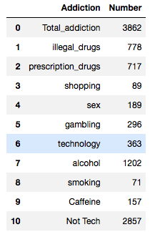

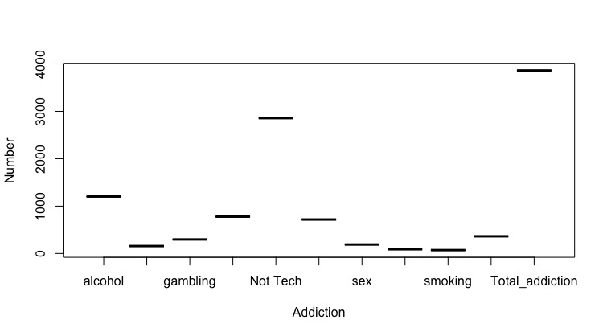

Addiction percentages (of total) are as follows: alcohol=31%, illegal_drugs=20%, prescription_drugs=19%, technology=9%, gambling=8%, sex=5%, Caffeine=4%, shopping=2%, smoking=2%. Therefore, the consideration that technology addictions are 50+% is not true as it’s only 9% currently.

Chi-squared test compared the addiction categories to the addiction treatment/recovery categories. The null value can not be rejected because p-value close to 0 (not above 0.5).

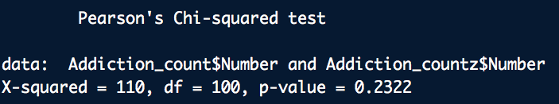

CONCLUSION

This search and analysis should be conducted in about six months to one year to see the change and whether there is any increase in technology related addictions.